LAB # 04
START,SLEEP AND STOP METHODS OF MULTITHREADING
OBJECT:
Understanding concurrency by implementing start, sleep and stop thread functions.
LAB TASK:
By using start, stop and sleep methods of threading, print alphabets of English from A-Z. (Hint:
use math.random method for getting random numbers and then convert them into characters, print
26 characters under run method loop with fluctuating visualization through sleep method).

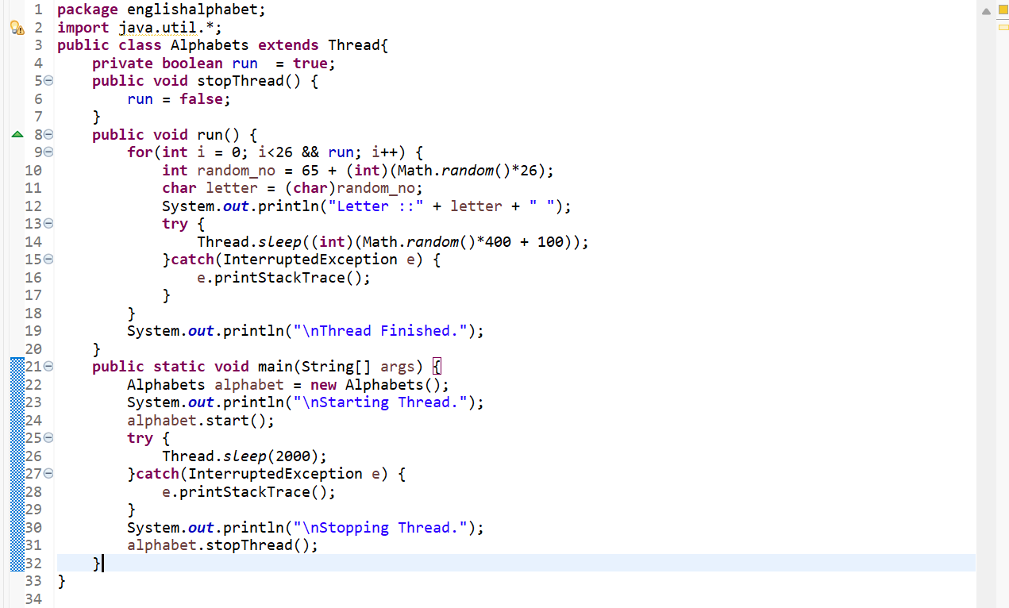
CODE:
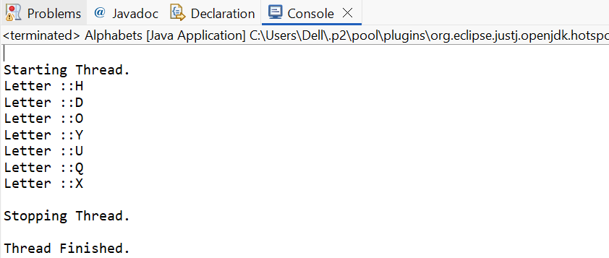
OUTPUT:

